Thank you for requesting for a quotation from Quality Safe Consultants Pte Ltd. The information provided in this application will enable us to provide you an accurate quotation to fulfil your audit and compliance requirements. Should you have any difficulties completing this form, please feel free to contact our officers who can guide you on the process and clarify any issues.

As this form is used to determine the audit programme, kindly do ensure the information provided is accurate and not misleading in any way. An authorized representative of your organization is required to verify the details provided and submit the completed questionnaire.

Lastly, the conditions set out in this document constitutes the legally enforceable requirements in accordance with auditing requirements between our AO and the client (i.e. organization seeking audit services or audited).

|  |  |  |  |  |  |  |
| --- | --- | --- | --- | --- | --- | --- |
| **PART 1: WORKPLACE / WORKSITE PARTICULARS** | | | | | | |
| Company Name | : | | | | | |
| Company Address | : | | | | | |
| Unique Entity Number (UEN) | : | | | | | |
| Factory Registration Number  (Not applicable for RM Audit) | : | | | | | |
| *Audit Site Address  (if different from company address)  (Not applicable for RM Audit) | : | | | | | |
| Contact Person | : | | Contact Number | | | : |
| Contact Email | : | | | | | |
| Total Organization Staff strength | : | | | | | |
| Total Site Staff Strength  (including sub-contractors) | : | | | | | |
| Industry  *Note: Our AO is accredited to conduct SHMS audits for construction worksite, metalworking industry and shipyards only. Our AO is accredited to conduct RM audits for all industries.* | :  Construction  Metalworking  Shipyard  Oil Refinery or Petrochemical Plant/ Semiconductor/ Wafer Fabrication Plant/ Chemical Manufacturing Plant/ Pharmaceutical Plant/ Bulk Storage Terminal  Others, Pls state: | | | | | |
| Audit Scope  *(This refers to nature of business activities. Examples: General Building Construction or Installation of Air Conditioners or Provision of Pest Control Services)* | : | | | | | |
| Audit Criteria | : | Shipyard | | Workplace Safety & Health Requirements for Marine Industries | | |
| : | Construction worksite | | Requirements for the Construction Safety Audit Scoring System (ConSASS) | | |
| : | Metalworking industry | | Requirements on the Implementation of Safety Management System for the Metalworking Industry | | |
| : | Oil refinery or petrochemical plant / Semiconductor wafer fabrication plant / Chemical manufacturing plant / Pharmaceutical plant / Bulk storage terminal | | SS 651 | | |
| : | Risk Management (RM) Audits for all industries | | Code of Practice on Workplace Safety and Health (WSH) Risk Management | | |
| For SHMS audit for construction and metalworking industries, please specify if initial audit or subsequent audit. | :  Initial  Subsequent | | | | | |
| Principal Activities  *(Example: Demolition works, General building construction, ship repair work, cleaning services, etc.)* | : | | | | | |
| Relevant Legal Obligations  *(Example: WSH Act, WSH (Risk Management) Regulations, WSH (Construction) Regulations, WSH (Shipbuilding and Ship-repairing) Regulations etc.)* | : | | | | | |
| Outsources processes  *(Please specify the work activities that are sub-contracted or given to third parties)* | : | | | | | |
| Total Number of Worksites | :  *For SHMS/ WSHMS audits, if there is more than one site to be audited, the application form shall be filled out for every site. For RM audits, at least 10% worksites will be covered during the audit. | | | | | |
| **PART 2: FOR RM AUDIT ONLY** | | | | | | |
| Location/ Site / Workplace Address | | | | | Nature of Work | |
|  | | | | |  | |
|  | | | | |  | |
|  | | | | |  | |
|  | | | | |  | |
|  | | | | |  | |
| Please attach separately if there are more than 5 locations/ sites/ workplaces or the space provided is insufficient. All locations/ sites/ workplaces must be specified. | | | | | | |
| **PART 3: AUDIT DETAILS (**Please tick only one box for each question in this part) | | | | | | |
| a) Has your organization engaged Quality Safe Consultants for any consultancy work previously? If yes, please elaborate: | | | | | | Yes  No |
| b) Has your parent organization or subsidiary organization engaged Quality Safe Consultants for any consultancy or outsourcing work previously? If yes, please elaborate: | | | | | | Yes  No |
| c) Has your organization engaged any consultant to assist on the management system to be audited? If yes, please specify the name of consultant organization: | | | | | | Yes  No |
| d) Are there any cultural or language considerations required for this audit? If yes, please elaborate: | | | | | | Yes  No |
| e) How would you rate the risk level/ complexity at the site to be audited?  Low  Medium  High  *\*For other industries as listed above, please refer to Appendix 2 below if uncertain* | | | | | | |
| f) Other relevant information (if applicable) | | | | | | |
|  | | | | | | |

**AUDIT TERMS AND CONDITIONS**

1. **Audit Application**
2. Organization seeking audit services will be provided the above Audit Application & Conditions Form. Upon filling out the form, QSC will conduct a review of the application to ensure any known differences are resolved, that QSC has the competence and ability to perform the audit activities and the site(s) of the applicant organization’s operations, time required to complete audits and any other points influencing the auditing activity are taken into account (language, safety conditions, threats to impartiality, etc.).
3. Upon review of the application, QSC will inform the applicant organization’s authorized representative through email, whether the application has been accepted or declined. Where the application is declined, the reasons for declining the application is documented and made clear to the client. The minimum time for conducting an audit will be determined in compliance to the requirements stipulated in Appendix 1 and 2 as per SAC CT 17.
4. Based on the audit time determination, a quotation will be sent to the audit applicant for endorsement. Upon acceptance of the application, an audit plan will be established and submitted to the audit applicant/ client. The audit plan will be communicated, and the dates of the audit agreed upon, in advance, with the client.
5. **Conducting on-site Audit**
6. Audit methodology will include conducting an opening meeting, reviewing previous audit findings, familiarization tour of the workplace, obtaining and verifying information (through interview of personnel, document or record review and physical inspection) and conduct of closing meeting.
7. Audit results and outcomes will be communicated during closing meeting to audit team.
8. **Reporting and completing an Audit**
9. An audit report will be provided within 30 days of the audit. The SAC mark will used on the first page of each audit report.
10. Our AO will also issue a testimony, without the use of SAC mark, for all audits conducted for its audited clients.
11. **Reference to auditing and use of marks**
12. The audited client shall not use or permit the use of the AO’s audit report or testimony or the AO’s mark in communication media such as the Internet, brochures or advertising, or other documents. The audited client shall not make or permit any misleading statement regarding the audit. The audited client shall not use or permit the use of an audit report or testimony or any part thereof in a misleading manner.
13. **Confidentiality**
14. The AO will inform the client, in advance, of the information it intends to place in the public domain. All other information, except for information that is made publicly accessible by the client, shall be considered confidential. Information about a particular audited client or individual shall not be disclosed to a third party without the written consent of the audited client or individual concerned.
15. When our AO is required by law or authorized by contractual arrangements (such as with the accreditation body) to release confidential information, the client or individual concerned shall, unless prohibited by law, be notified of the information provided.
16. Information about the client from sources other than the client (e.g. complainant, regulators) shall be treated as confidential, consistent with our AO's policy.
17. Personnel, including any committee members, contractors, personnel of external bodies or individuals acting on our AO’s behalf shall keep confidential all information obtained or created during the performance of our activities except as required by law.
18. Our processes and where applicable equipment and facilities that ensure the secure handling of confidential information.
19. **Information exchange between our AO and our clients**
20. Our AO shall provide information and update clients on the following:
21. a detailed description of the initial audit activity, including the application
22. the normative requirements for auditing
23. information about the fees for application and auditing
24. our AO requirements for clients to:

1) comply with auditing requirements

2) make all necessary arrangements for the conduct of the audits, including provision for examining documentation and the access to all processes and areas, records and personnel for the purposes of audit and resolution of complaints

3) make provisions, where applicable, to accommodate the presence of observers (e.g. accreditation assessors or trainee auditor)

1. documents describing the rights and duties of audited clients, including requirements, when making reference to its auditing in communication of any kind
2. information on processes for handling complaints
3. **Notice of changes by our AO**
4. We will give our audited clients due notice of any changes to its requirements for auditing. We will verify that each audited client complies with the new requirements.
5. **Notice of changes by audited clients**
6. This document serves as a legally enforceable arrangement to ensure that the audited client informs our AO, without delay, of matters that may affect the capability of the management system to continue to fulfil the requirements of the standard used for auditing. These include, for example, changes relating to:
7. the legal, commercial, organizational status or ownership
8. organization and management (e.g. key managerial, decision-making or technical staff)
9. contact address and sites
10. scope of operations under the audited management system
11. major changes to the management system and processes
12. We will take action as appropriate.
13. **Complaints**
14. The AO appreciates all feedback received with regards to its auditing service and gives utmost importance to all complaints received.
15. Feedback or complaints can be submitted as follows:
    1. Telephone (Please contact our main line at 6261 8150)
    2. Email (Please email to [enquiry@qualitysafe.com.sg](mailto:enquiry@qualitysafe.com.sg))
    3. Engagement with our sales officer
    4. Filling out our Feedback Form (ASP-06-F01)
16. Submission, investigation and decision on complaints will not result in any discriminatory actions against the complainant.
17. Your complaints will be routed to our Head of Audit within 3 working days.
18. Request to appeal of audit decisions or outcomes will not be entertained due to the nature of audits performed.
19. Whenever possible, the requestor of the complaint will be notified of the corrections, corrective actions or decision not take actions in writing or otherwise. The decision to be communicated to the complainant is made by, or reviewed and approved by, individual(s) not previously involved in the subject of the complaint. Whenever possible, our AO will give formal notice of the end of the complaints-handling process to the complainant.
20. All complaints received are subject to requirements for confidentiality, as it relates to the complainant and to the subject of the complaint. We will determine, together with the audited client and the complainant, whether and, if so to what extent, the subject of the complaint and its resolution will be made public.
21. **Witness Assessment**
22. If the AO’s audited client does not allow SAC to witness the audit, the client may not be provided with a SAC accredited report. SAC will also inform all its accredited AOs of the client. If the client chooses to seek auditing services from another AO, SAC will inform the new AO that it wishes to witness the audit.

**APPENDIX 1: AUDIT MAN DAY/ TIME DETERMINATION**

**For SHMS/ WSHMS audits,**

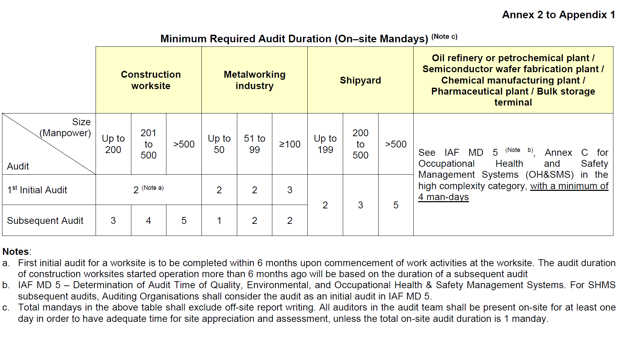

**For Risk Management audits,**

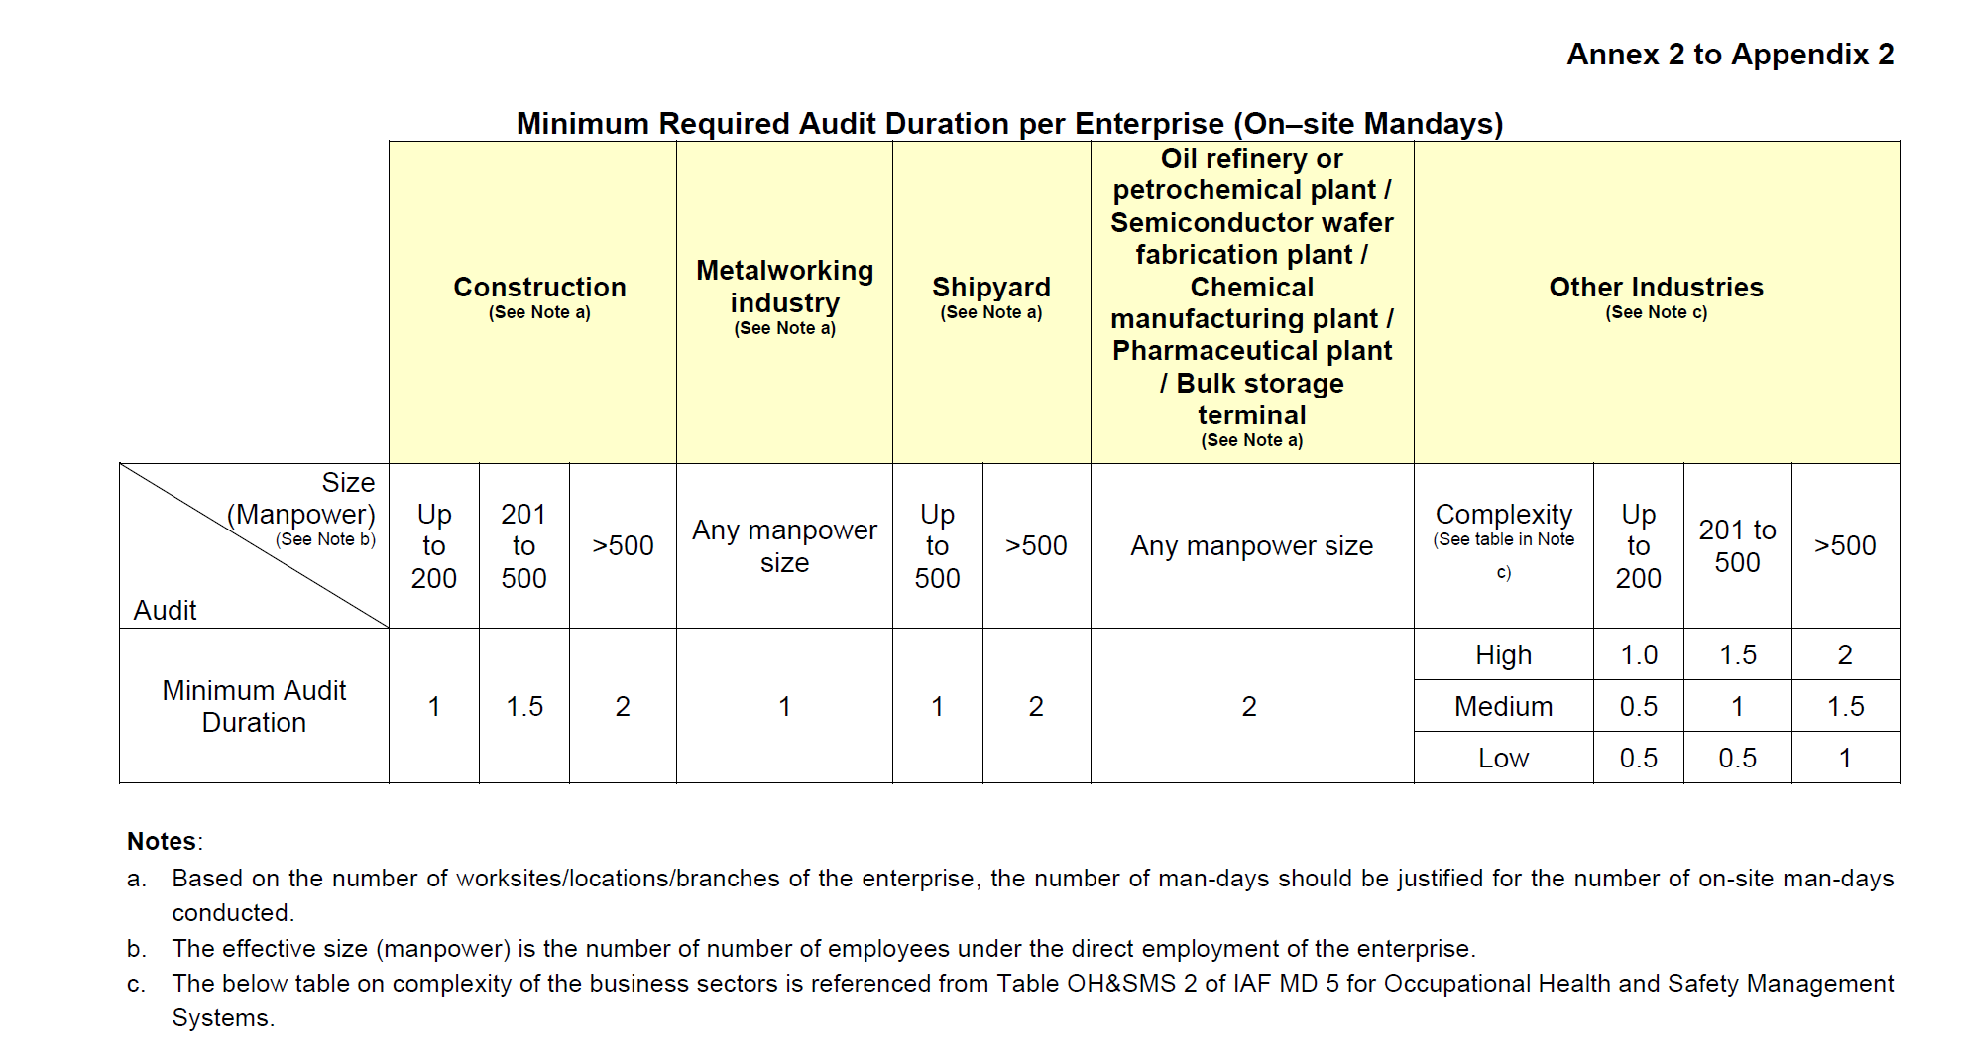

**APPENDIX 2: COMPLEXITY BASED ON BUSINESS SECTOR**

|  |  |
| --- | --- |
| **Complexity** | **Business Sector** |
| High | * fishing (offshore, coastal dredging and diving) * mining and quarrying * manufacture of coke and refined petroleum products * oil and gas extraction * tanning of textiles and clothing * pulping part of paper manufacturing including paper recycling processing * oil refining * chemicals (including pesticides, fabrication of batteries and accumulators), and pharmaceuticals * manufacturing of fibreglass * gas production, storage and distribution * electricity generation and distribution * nuclear * storage of large quantities of hazardous material * non-metallic processing and products covering ceramics, concrete, cement, lime, plaster, etc. * primary productions of metals * hot and cold forming and metal fabrication * manufacturing and assembly of metal structures * aerospace industry * automotive industry * manufacturing of weapons and explosives * recycling of hazardous waste * hazardous and non-hazardous waste processing e.g. incineration etc. * effluent and sewerage processing * industrial and civil construction and demolition (including building completion with electrical, hydraulic and air conditioning installation activities) * slaughter houses * transport and distribution of dangerous goods (by land, air and water) * defence activities/crisis management * healthcare/hospitals/veterinary/social works |
| Medium | * aquaculture (breeding, rearing, and harvesting of plants and animals in all types of water environments) * fishing (offshore fishing is high) * farming/forestry (depending on the activities could be high) * food, beverage and tobacco – processing * textiles and clothing except for tanning * manufacturing of wood and wooden products including manufacturing of boards, treatment/impregnation of wood * paper production and paper products excluding pulping * non-metallic processing and products covering glass, ceramics, clay, etc. * general mechanical engineering assembly * manufacturing of metallic products * surface and other chemically based treatment for metal fabricated products excluding primary production and for general mechanical engineering (depending on the treatment and the size of the component could be high) * production of bare printed circuit boards for electronics industry * rubber and plastic injection moulding, forming and assembly * electrical and electronic equipment assembly * manufacturing of transport equipment and their repairs - road, rail and air (depending on the size of the equipment, could be high) * recycling, composting, landfill (of non-hazardous waste) * water abstraction, purification and distribution including river management (note commercial effluent treatment is graded as high) * fossil fuel wholesale and retail (depending on the amount of fuel, could be high) * transport of passengers (by air, land and sea) * transport and distribution of non-dangerous goods (by land, air and water) * industrial cleaning, hygiene cleaning, dry cleaning normally part of general business services * research & development in natural and technical sciences (depending on the business sector could be high). Technical testing and laboratories * hotels, leisure services and personal services excludes restaurants * education services (depending on the object of teaching activities could be high or low) |
| Low | * corporate activities and management, HQ and management of holding companies * wholesale and retail (depending on the product, could be medium or high, e.g. fuel) * general business services except industrial cleaning, hygiene cleaning, dry cleaning and education services * transport and distribution - management services with no actual fleet to manage * engineering services (could be medium depending on type of services) * telecommunications and post office services * restaurants and campings * commercial estate agency, estate management * research & development on social sciences and humanities * public administration, local authorities * financial institutions, advertising agency |

|  |
| --- |
| **DECLARATION BY APPLICANT ORGANIZATION** |
| I acknowledge that the above information provided in accurate and not misleading in any way.  I also acknowledge acceptance of the above terms and conditions.  Name:       Signature:  Designation:       Date: |
| **FOR AUDITING ORGANIZATION OFFICIAL USE** |
| Application is  Accepted  Declined  Please state reason if application is declined:  Audit time determination:  0.5 Man Day  1.0 Man Day  1.5 Man Day  2.0 Man Day  2.5 Man Day  3.0 Man Day  4.0 Man Day  5.0 Man Day    Justification for audit time determination (based on Appendix 2):  Low Risk  Medium Risk  High Risk  Selected audit team:  Name of deciding officer: Vishnu Lal Date of Review:       Signature:  Project site selected for RM Audit: |